**Summary of A reference SET OF CONDITIONED operating models for atlantic bluefin tuna**

Tom Carruthers[1], Doug Butterworth[2]

*SUMMARY*

A total of 36 reference case operating models for Atlantic bluefin tuna are described that span a range of scenarios for future recruitment dynamics, current abundance levels, natural mortality rate and age at maturity. Of these operating models 12 required fitting to historical data. The fits of these models to data are presented in this paper. The various operating models fitted similarly well to the indices and none appeared to warrant rejection from the reference set. The fitted reference operating models span a reasonably wide range of estimates for stock status and productivity. A number of fishery-independent and assessment CPUE indices had acceptable fitting diagnostics. These indices span younger and older life stages in both eastern and western areas and could index-based MPs of varying complexity.

*KEYWORDS*

*Management Strategy Evaluation, bluefin tuna, operating model, management procedure*

# Introduction

A Management Strategy Evaluation (MSE, Butterworth and Punt 1999, Cochrane 1998) approach has been proposed for Atlantic bluefin tuna as a suitable framework for providing robust management advice consistent with the precautionary approach (GBYP 2017a). A principal task in the construction of an MSE framework is the development of operating models which represent credible hypotheses for population and fishery dynamics. Operating models are typically fishery stock assessment models which are fitted to data to ensure that model assumptions and estimated parameters are empirically credible (Punt et al. 2014, e.g. CCSBT 2011).

A general approach for testing MPs using MSE established two sets of operating models. The reference set of trials are considered to reflect the most plausible hypotheses which also have a marked impact on stock dynamics, and are the primary basis for identifying the best performing management procedure. Robustness trials are used to determine whether the management procedure behaves as intended in scenarios that are less likely.

In this paper the design of the reference set of operating models is described including the fit of these models to data (their “conditioning”). The operating models will be used to test a range of MPs that use indices of abundance to calculate TAC advice. The fit of the operating model to abundance indices informs which indices might best be used in MPs, and hence need to be included in MSE testing (i.e. what indices need to be simulated for this process).

# Methods

Seasonal, spatial, multi-stock, age structured operating models were fitted to a wide variety of fishery dependent and independent data (see Carruthers et al. 2015a and CMG 2017). Such data included electronic tags, Task II catch rate data and micro-constituent data informing stock of origin (for a summary of these data see Carruthers et al. 2015b and GBYP 2017b).

A reference set of operating models was identified that spanned three main axes of uncertainty for Atlantic bluefin tuna: (1) future recruitment, (2) abundance and its trends, and (3) age-at-maturity (spawning fraction) / natural mortality rate (see Tables 1 and 2 for the reference operating model set design). Although this leads to 36 reference operating models in total, future recruitment scenarios do not impact model fitting. Consequently 12 unique model fits are presented here that cover factors 2 and 3 relating to abundance and trends, and to maturity and natural mortality rate (the grey rows of Table 2).

# Results

**Model estimates for the base-case reference model #1**

Operating model #1 consists of the first levels of all factors, namely MPD ‘best’ estimate of abundance from the operating model (with no additional priors), low age at maturity and high natural mortality rate. For this reference case OM the model provides estimates of eastern area biomass that are similar to those from the VPA and Stock Synthesis (SS) assessments (Figure 1a). The trend however is more positive than for those assessments and follows an upward trajectory over 1988 – 2015. However, the very recent 3-fold increases in spawning biomass for the eastern stock that are estimated by the VPA assessment are not matched by the fitted OM #1.

OM #1 estimates of western spawning biomass are substantially higher on average than those from the VPA and SS assessments (around 39 000 tonnes from 1983-2015 compared to 28 000 t and 21 000t for the VPA and SS assessments respectively) (Figure 1a). The trend in spawning biomass is also different showing maximum biomass around 2003 rather than 2015 for the two assessments.

**Mimicking assessments: Factor 2, abundance**

OMs #4 and #7 are departures from OM #1 in that they use priors which intend to obtain similar mean abundance to the VPA assessments (OM #4, Factor 2 level 2) and an increase in the Eastern SSB similar to the Eastern VPA assessment (OM #7, Factor 2 level 3). Figures 1b and 1c illustrate that these prior specifications were largely successful in attaining their objectives.

**All OM model estimates**

In general the 12 fitted operating models span a reasonably wide range of simulated stock parameters and behaviour. MPD model estimates of FMSY ranged from 0.14 – 0.31 for the Eastern stock (Table 3) and 0.08-0.23 for the Western stock (Table 4). Stock depletion at present (current SSB relative to its unfished level) ranged from 0.32 – 0.8 for the East stock and 0.3 – 0.45 for the Western stock.

With the exception of factor 2 level C, where very recent increases in the East matched the specifications from a prior, there was not a substantial difference in the trajectories for the two stocks among the various operating models (Figure 4).

**Fit to indices of abundance**

The following indices did not show problematic patterns in residuals (Figure 2a and 2b) and are likely to be collected in the future.

Eastern, fishery dependent: JPN_LL_NEAtl2

Eastern, fishery independent: FR_AER_SUV, MED_LAR_SUV, MED_AER_SUV

Western, fishery dependent: JPN_LL2, US_RR_66_114

Western, fishery independent: GOM_LAR_SUV

These indices may be considered as candidates for simulation in the MSE framework for the calculation of TACs by MPs.

**Effect of OM factors**

In terms of the harvest rate at maximum sustainable yield (UMSY), the most important Factor was 3, which includes various scenarios for age at maturity and the natural mortality rate. Lower natural mortality rates and older ages at maturity led to lower UMSY values for both stocks. The impact of natural mortality rate (I vs III, II vs IV) was much higher on the UMSY estimates for the western stock however, and made little different to UMSY estimates for the eastern stock.

Depletion estimates were also affected by the maturity and natural mortality rate with the most pessimistic estimates arising from the lower natural mortality rate scenarios II and IV.

**Statistical properties of indices**

In order to simulate realistic relative abundance indices it is necessary to characterize the properties of operating model fitting to these data. Two principal properties are residual error and auto-correlation in residual errors. These specify the the degree of annual error in simulated indices in addition to the propensity to simulate runs of residuals where the index is above or below the true relative biomass for multiple years (Table 5).

# Discussion

In general, the various reference operating models span a reasonably wide range of scenarios for stock status and productivity. While even the best fits to indices showed some residual patterns, the observation model can account for misfit by simulating auto-correlation in residuals and hyper-stability.

The principal purpose of this document is to investigate whether certain operating models do not meet acceptable standards of model fit. The various operating models fitted similarly well to the indices and none appeared to warrant rejection from the reference set.

A number of fishery-independent and assessment CPUE indices may be available that span younger and older life stages in both eastern and western areas. It follows these provide a basis for investigating a range of index-based MPs of varying complexity.

# Acknowledgements

This work was carried out under the provision of the ICCAT Atlantic Wide Research Programme for Bluefin Tuna (GBYP), funded by the European Union, several ICCAT CPCs, the ICCAT Secretariat and by other entities (see: http://www.iccat.int/GBYP/en/Budget.htm). The contents of this paper do not necessarily reflect the point of view of ICCAT or other funders and in no ways anticipate ICCAT future policy in this area.

# References

ABT-MSE. 2017. Atlantic bluefin tuna management strategy evaluation: an R package. Available at: [accessed September 2017]

Butterworth, D.S., Punt, A.E., 1999. Experiences in the evaluation and implementation of management procedures. ICES J. Mar. Sci. 56, 985-998.

Carruthers, T.R., Kimoto, A., Powers, J., Kell, L., Butterworth, D., Lauretta, M. and Kitakado, T. 2015a. Structure and estimation framework for Atlantic bluefin tuna operating models. ICCAT SCRS/2015/179.

Carruthers, T.R., Powers, J., Lauretta, M., Di Natale, A., Kell, L. 2015b. A summary of data to inform operating models in management strategy evaluation of Atlantic bluefin tuna. ICCAT SCRS/2015/180.

CMG. 2017. Specifications for MSE trials for bluefin tuna in the North Atlantic. GBYP Core Modelling Group. ICCAT Atlantic Wide Research Programme for Bluefin Tuna. Available at: [https://github.com/ICCAT/abft-mse/tree/master/Manuals_and_design_documents/Trial Specifications.docx](https://github.com/ICCAT/abft-mse/tree/master/Manuals_and_design_documents/Trial%20Specifications.docx) [accessed September 2017]

GBYP. 2017a. ICCAT Atlantic wide research programme for Bluefin Tuna. Available online at: http://www.iccat.int/GBYP/en/index.htm [accessed September 2017]

GBYP. 2017b. Data to inform operating models for North Atlantic bluefin tuna. ICCAT Atlantic Wide Research Programme for Bluefin Tuna. Available at: <https://drive.google.com/drive/folders/0B0TXcs-MLRl3anc2Sjc0Yjk1ZTA> [accessed September 2017]

Cochrane, K L., Butterworth, D.S., De Oliveira, J.A.A., Roel, B.A., 1998. Management procedures in a fishery based on highly variable stocks and with conflicting objectives: experiences in the South African pelagic fishery. Rev. Fish. Biol. Fisher. 8, 177-214.

Punt, A.E., Butterworth, D.S., de Moor, C.L., De Oliveira, J.A.A., Haddon, M., 2016. Management strategy evaluation: best practices. Fish Fish. 17, 303–334, http://dx.doi.org/10.1111/faf.12104.

## Table 1. The factors and associated levels which define the reference set of operating models.

|  |  |  |
| --- | --- | --- |
|  | West | East |
| Future recruitment | |  |
| 1 | Hockey-stick | 83+ B-H with *h*=0.98 |
| 2 | B-H with *h* estimated | 83+ B-H with *h*=0.70 |
| 3 | Hockey-stick changes to  B-H after 10 years | 83+ B-H with *h*=0.98 changes to 50-82 B-H with *h*=0.98 after 10 years |
| Abundance | |  |
| A | Best estimate | |
| B | East and West area spawning biomasses match VPA assessment in absolute terms | |
| C | Recent eastern area SSB increases 3x to match VPA assessment | |
| Maturity (both stocks) | | Natural Mortality (both stocks) |
| I | Younger | High |
| II | Younger | Low |
| III | Older | High |
| IV | Older | Low |

## Table 2. The design of reference set of operating models. Note that only future recruitment level 1 is presented in this paper (grey shaded rows) since the future recruitment scenario does not impact the fits of the operating models to past data.



**Table 3**. Operating model estimates (maximum posterior density) for the Eastern stock. OM refers to the operating model umber (Table 2). FMSYa is apical fishing rate corresponding to MSY.UMSY is harvest rate at MSY. SSBrel is SSB at MSY (SSBMSY) relative to unfished (SSB0). recMSY is the fraction of unfished recruitment at MSY. D is current spawning stock depletion, while Dep is biomass depletion. The OFL is the overfishing limit and is the catch corresponding to FMSY fishing of the current vulnerable biomass.

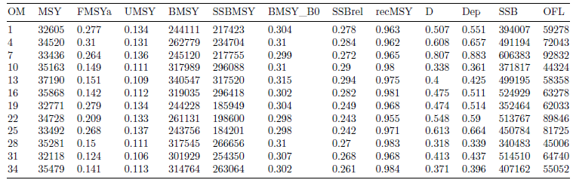

**Table 4**. As Table 3 but for the Western stock.

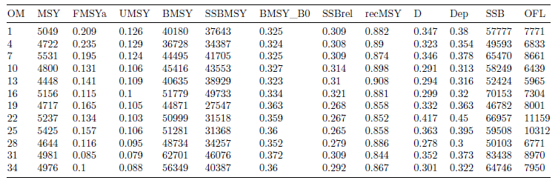

**Table 5.** Statistical properties of fits to indices assuming linearity and non-linearity. Residual error is expressed as a standard deviation of the log-space observed – predicted values. Autocorrelation is lag-1 autocorrelation in log residuals. Residual error and autocorrelation were calculated for each of the 96 simulations. The 5th, median and 95th percentiles of these statistics are reported for each index. The non-linearity is modelled by the beta parameter, I = q SSB ^ beta



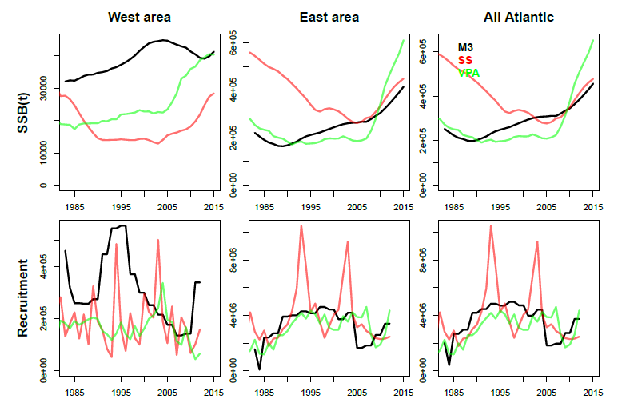

**Figure 1a.** Similarity of M3 operating model estimates (OM #1) with Western and Eastern assessments (2017).

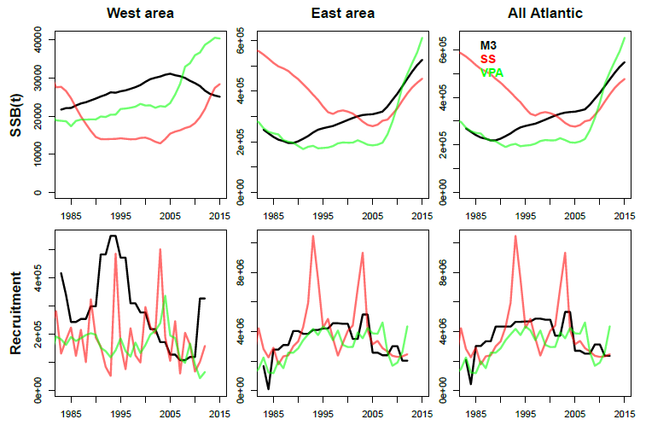

**Figure 1b.** Similarity of M3 operating model estimates (OM #4) with Western and Eastern assessments (2017). This operating model differs from OM#1 (Figure 1a above) in that it corresponds to level B for factor 2 (abundance) and the mean spawning biomass levels in absolute terms in the East and West areas have an informative prior that matches the VPA assessments.

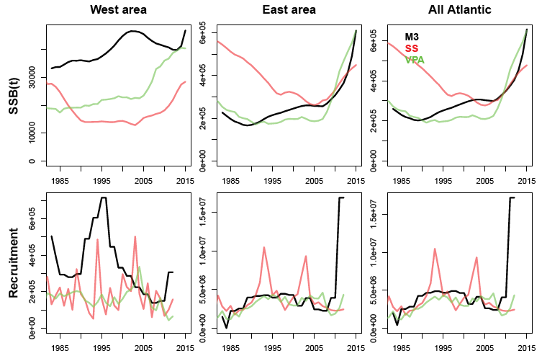

**Figure 1c.** Similarity of M3 operating model estimates (OM #7) with Western and Eastern assessments (2017). This operating model differs from OM#1 (Figure 1a above) in that it corresponds to level C for factor 2 (abundance) and the trend in Eastern areas SSB over the last 9 years has an informative prior for M3 to be able to match the three fold increase in the Eastern VPA assessment.

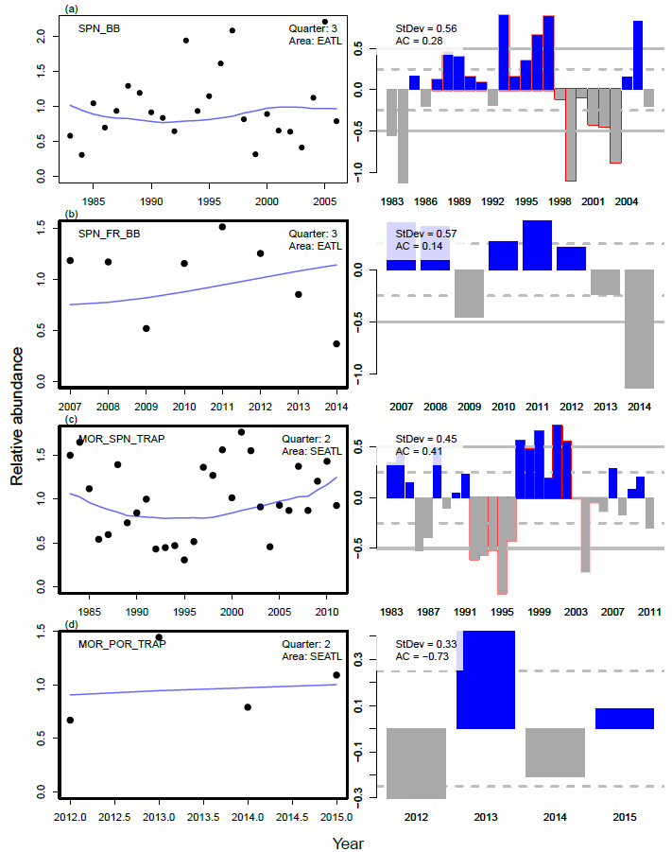 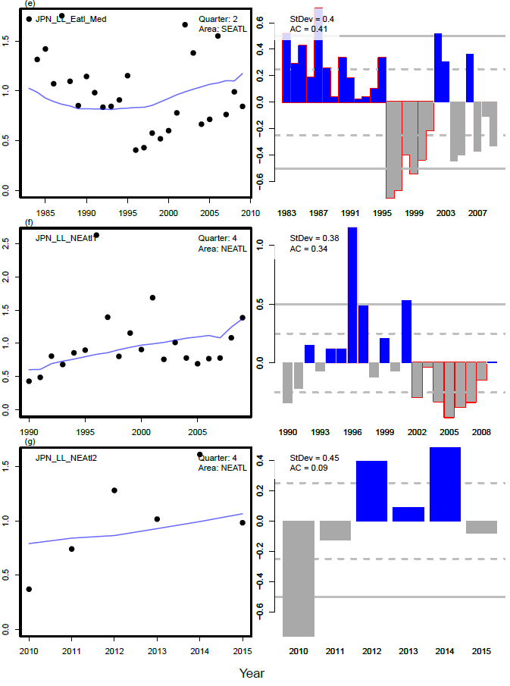

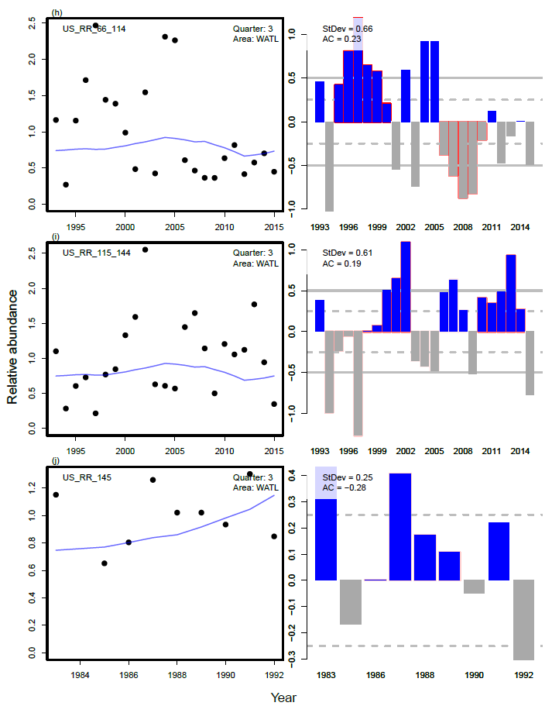 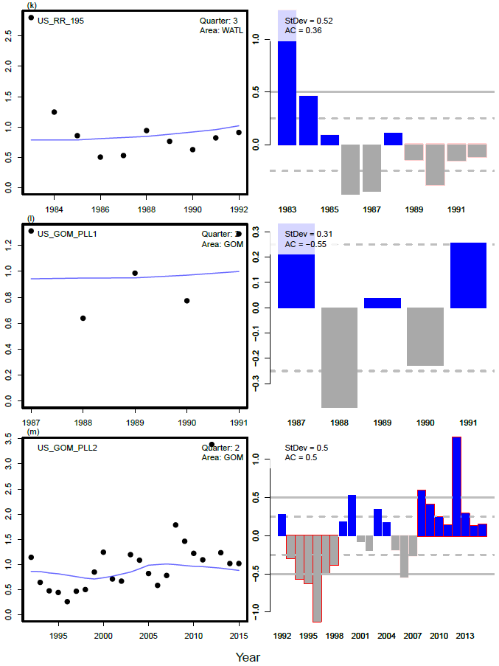

**Figure 2a.** Fit of OM#1 to CPUE indices used in both he stock assessments and the conditioning of these operating models.

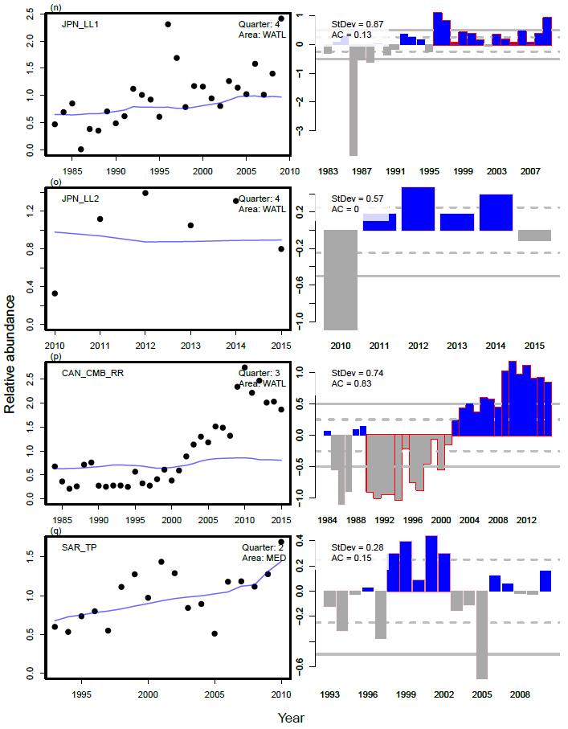 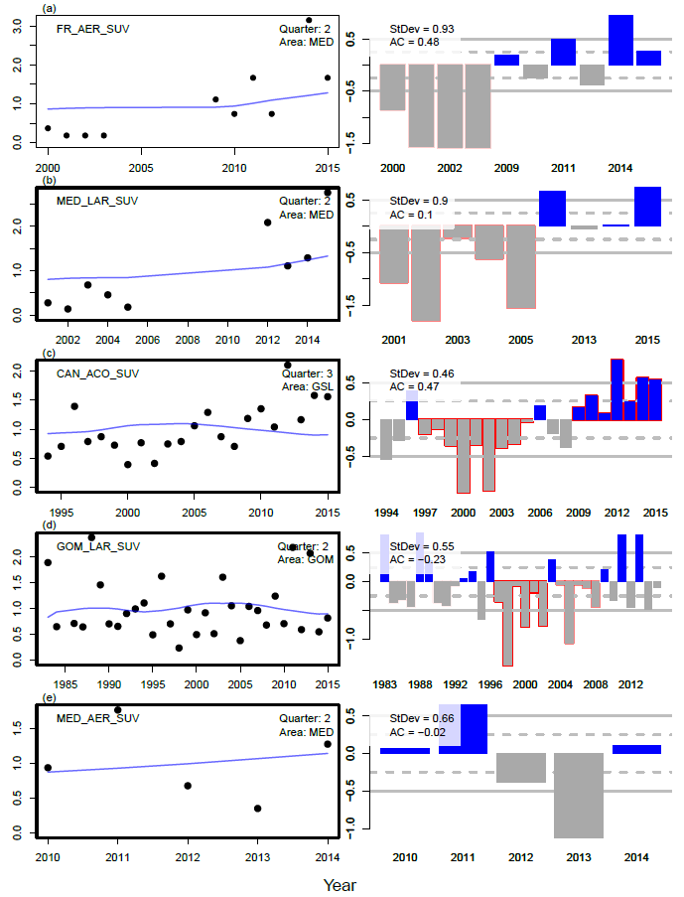

**Figure 2b.** Fit of OM#1 CPUE indices and fishery independent indices used in the stock assessment and the conditioning of these operating models

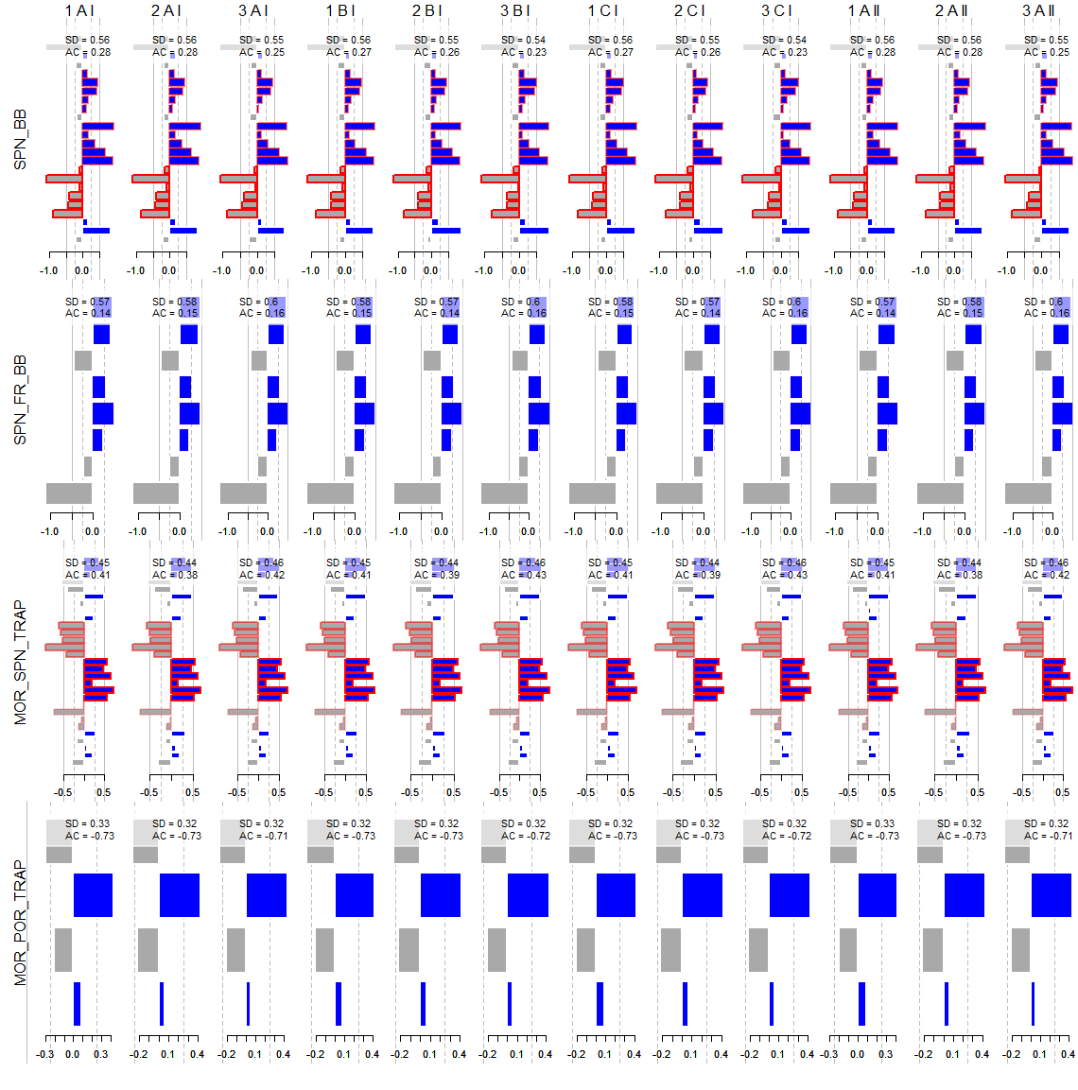

**Figure 3a**. Residuals for all operating model fits (columns) to various assessment indices (rows)

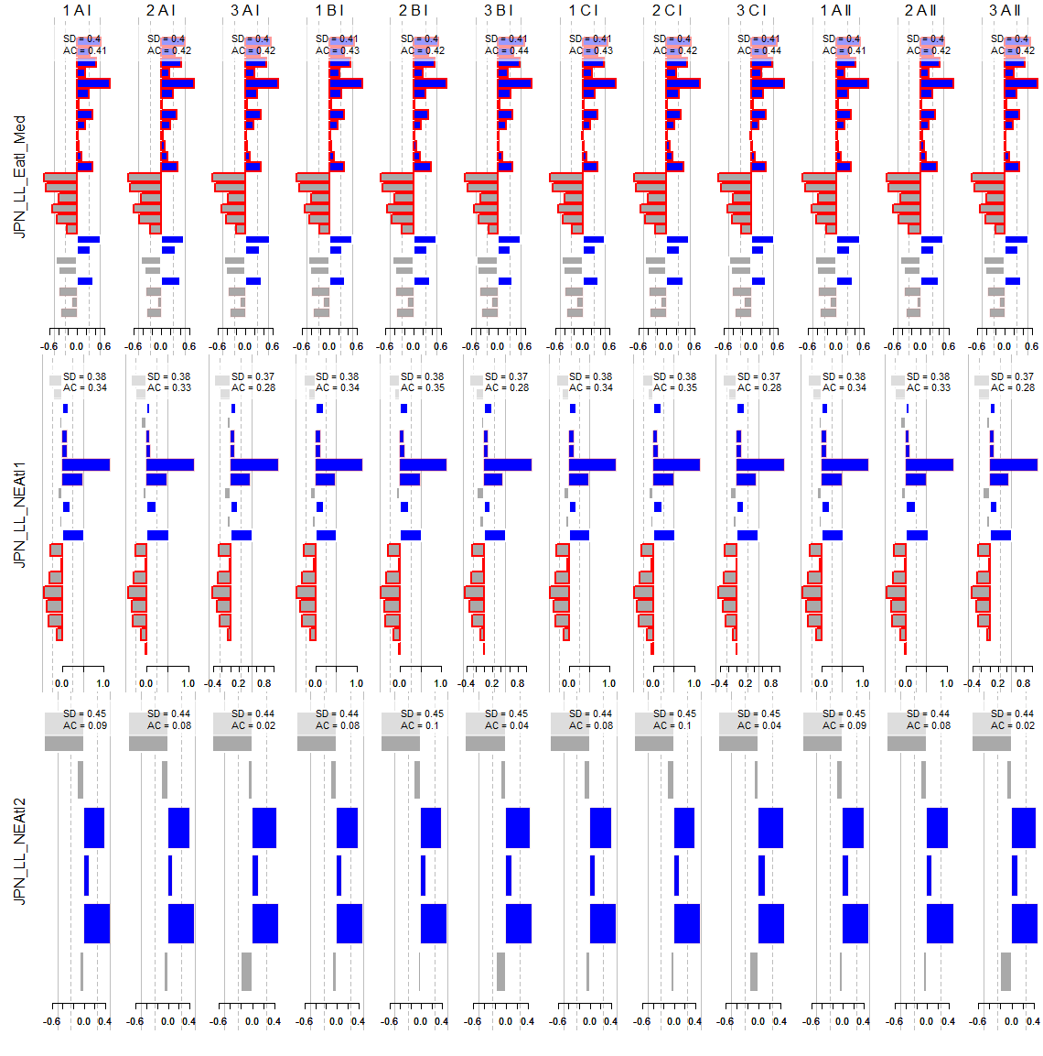

**Figure 3b**. Residuals for all operating model fits (columns) to further assessment indices (rows)

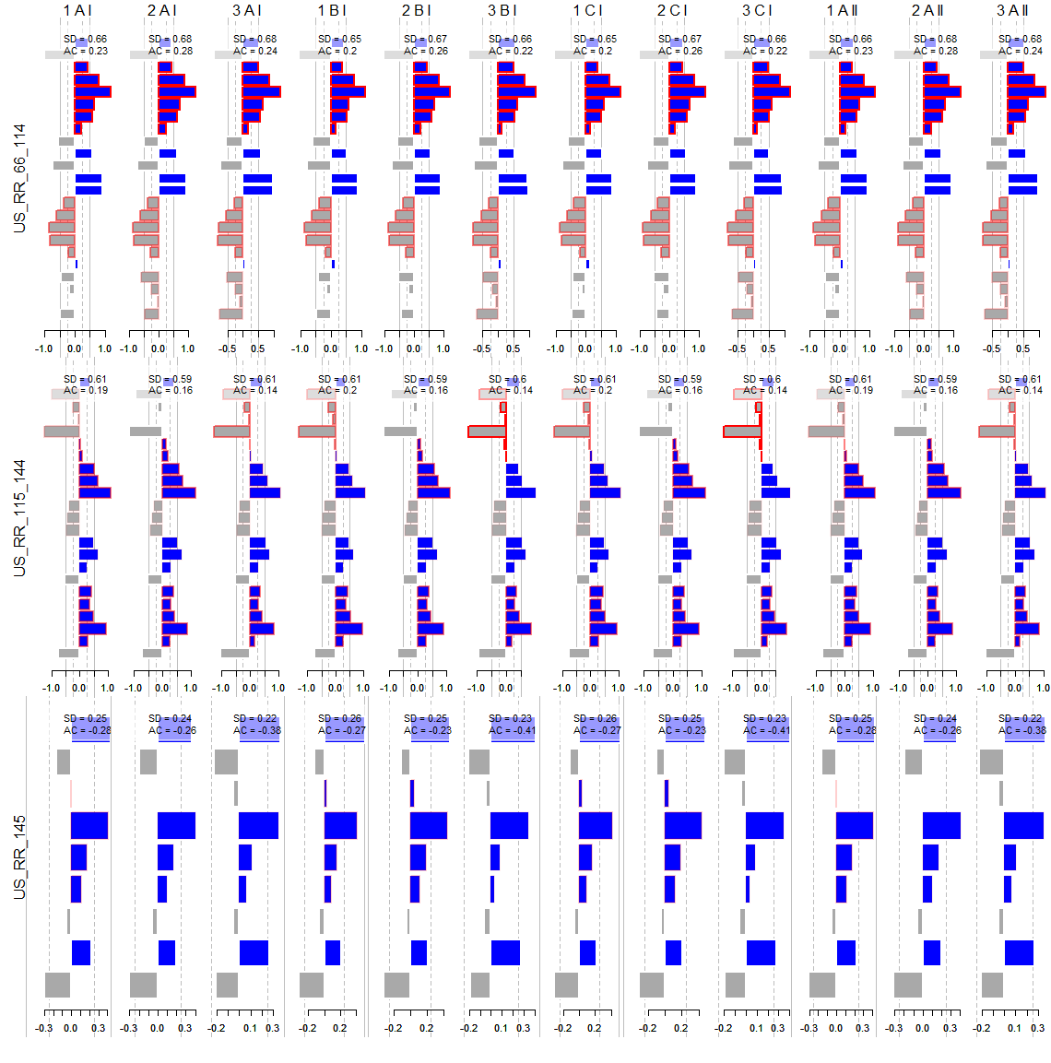 **Figure 3c**. Residuals for all operating model fits (columns) to yet further assessment indices (rows)

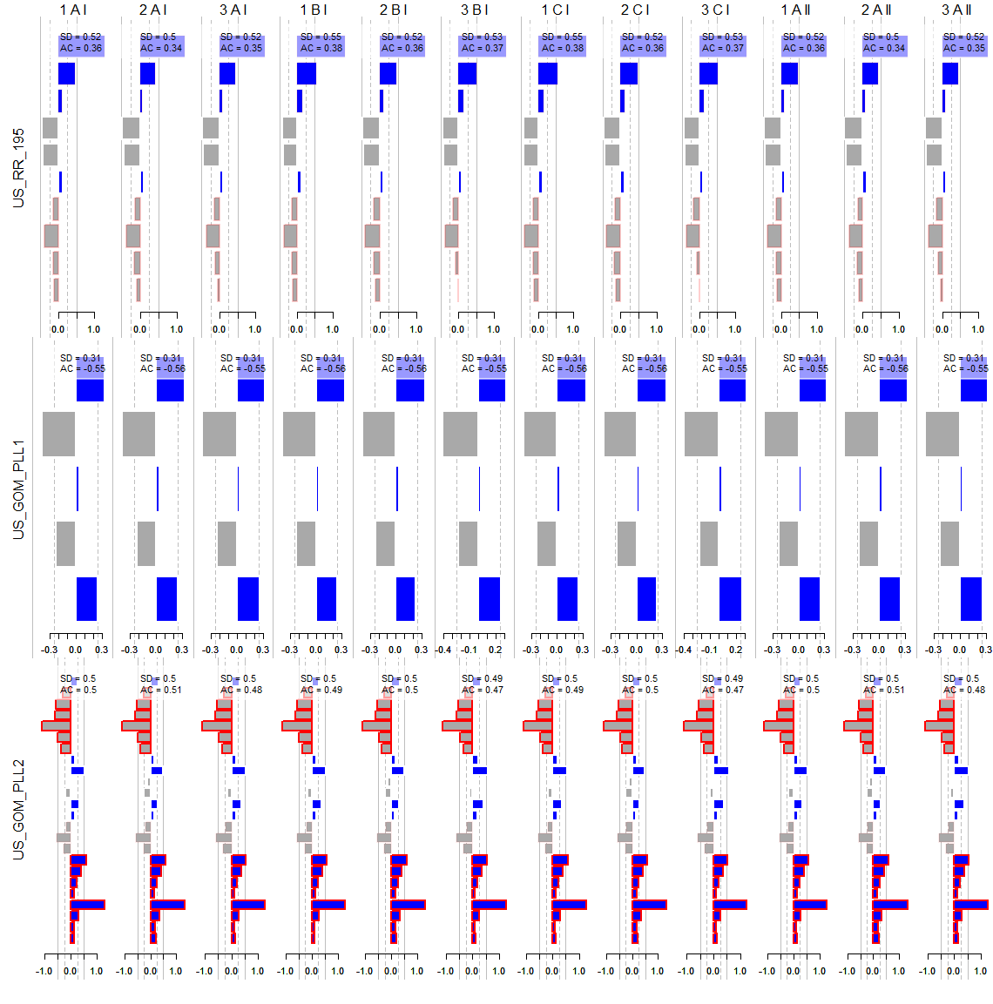

**Figure 3d**. Residuals for all operating model fits (columns) to still more assessment indices (rows)

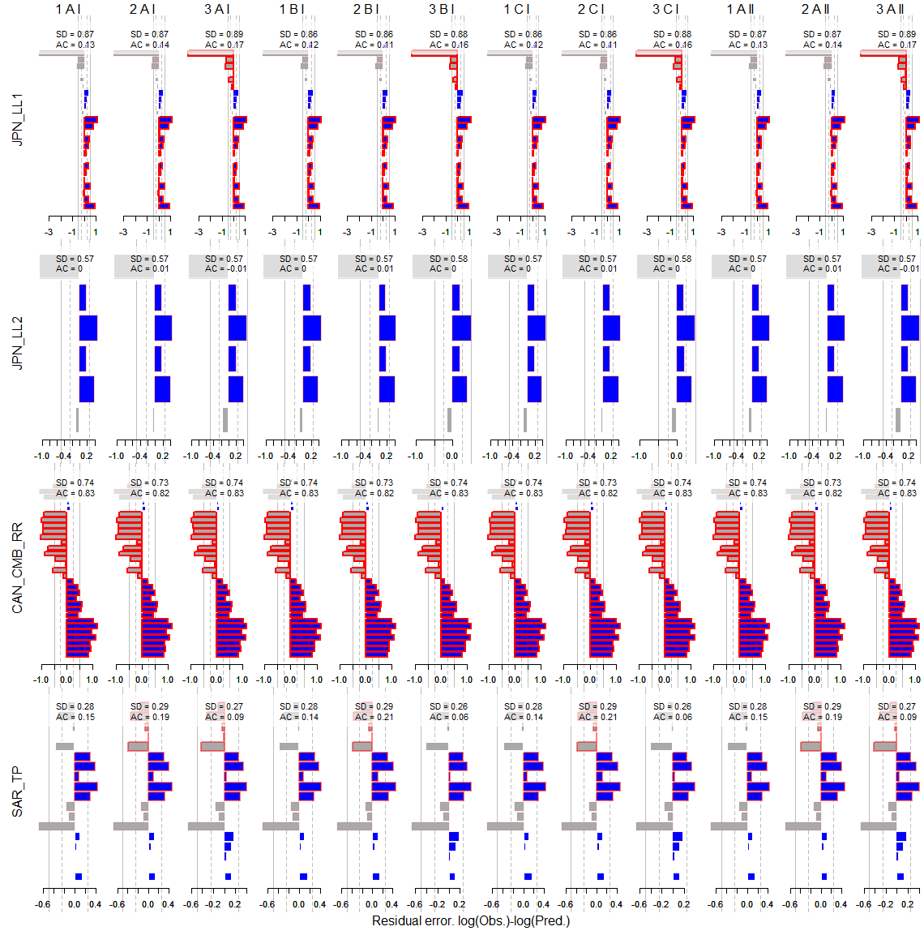

**Figure 3e**. Residuals for all operating model fits (columns) to the still remaining assessment indices (rows)

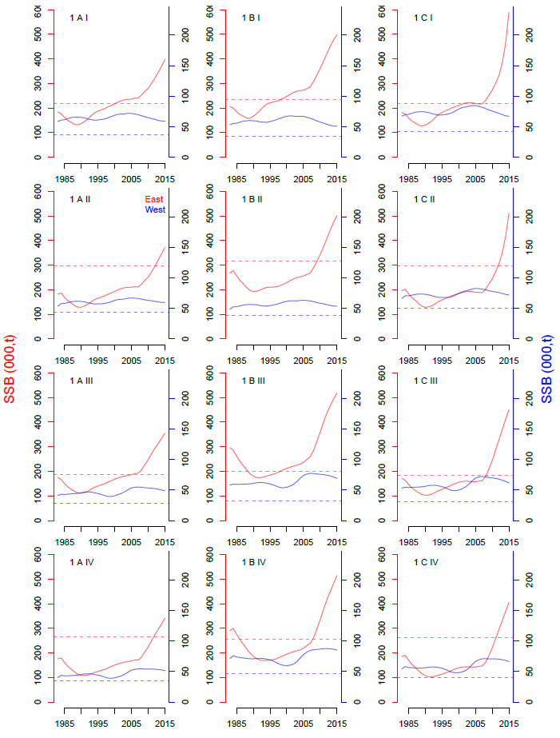

**Figure 4.** Predicted spawning biomass (East and West stocks) for each operating model (maximum posterior density estimates) (note that these results differ from those for East and West areas because of stock mixing).

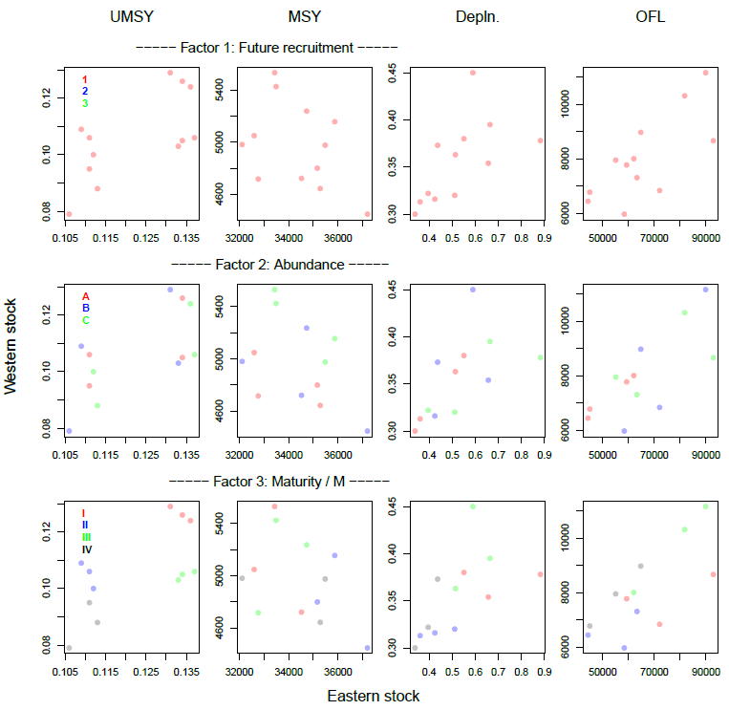

**Figure 5**. The effect of factors and their levels on OM model estimates. Each panel shows model estimates for the Eastern (horizontal axis) and Western (vertical axis) stocks for four quantities, harvest rate at MSY (UMSY), maximum sustainable yield (MSY), stock depletion (current SSB relative to unfished, ‘Depln’) and the over fishing limit (UMSY multiplied by current vulnerable biomass). Note that values of these quantities are not affected by whichever of the three levels of factor 1 applies.

1. IOF, 2202 Main Mall, University of British Columbia, Vancouver, B.C., Canada, V6T 1Z4. [t.carruthers@oceans.ubc.ca](mailto:t.carruthers@oceans.ubc.ca)
2. Dept Maths and Applied Maths, University of Cape Town, Rondebosch 7701, South Africa. [doug.butterworth@uct.ac.za](mailto:doug.butterworth@uct.ac.za)